**Lesson 2 Changing graphics using the templates**

Good to hear that the compiling worked! That means we can mess around with some graphics!  
Thnx for the DOS tips and good that you know your way around that, especially getting back to the last command typed (I use the Arrow-up by the way) as that is very usefull later on :W  
  
Ok, lets get you going on changing the graphics and setting up two graphicssheets (using for example your blackish and brownish platforms you drew) that we will use later on for expanding the code.  
  
Use this one as a base (its also already in the gfx folder):

**Attachment:**

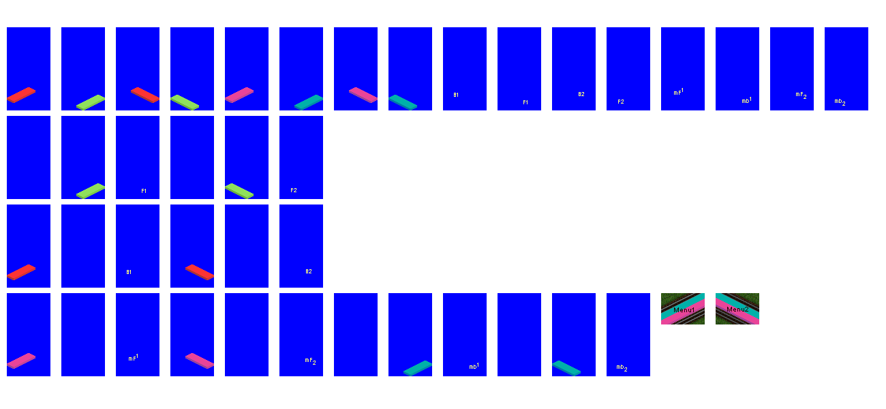  
Zoom in (real dimensions: 1300 x 600)  
Template_RegularPlatform_32bpp_BASE.png [ 26.18 KiB | Viewed 67 times ]

This has the four types of regular platforms, with an added extra (that I will explain later)  
- row-1: Standard old school style OpenTTD platform setup (platforms on each side of the track, with the extra graphics when you drag the station over a couple of tiles)  
- row-2: Single sided platforms, only at front of track  
- row-3: Single sided platforms, only at back of track  
- row-4: Island platforms, only in the middle of two tracks  
  
When drawing completely new platforms (like those black and brown ones), I believe it is best to give a player all 4 options as some like to use the oldschool style and others may like the singlesided ones (or both, the more options, the more fun ;-))  
As you can see from the various colored platforms, you can use the same graphics for the various options (not necessary ofcourse, each can have custom graphics, but this gets you a lot of different types of platforms with little graphical work)  
  
I would say, change this template with your graphics ;-)Please do note the shading of the foundations, it will look better if you keep that in mind. The foundations dont have to be fully drawn, you can draw tiny poles if you want. Also the platforms dont have to be this size, they can be smaller if you want (or have a ramp/stairs going up/down). But this is the size for them to link up completely to each other. It is also the biggest size they should have without overlapping the tracks or getting graphical glitches. They can have structures on them ofcourse, or roofs, or other things high over tracks so trains pass under them, but that is for the advanced class ;-)(it means changing the values for the boundingboxes in the code, better to discuss that when you are comfortable with the basics)  
  
The only thing you may not be able to draw before coding it and actually using it ingame are the two purchasemenu-sprites at the end of row-4. I usually draw and code the Island Platforms and then make a screenshot and use the screenshot for the purchasemenu-sprites and recompile the GRF.  
The first 3 rows make their purchasemenu sprites automatically, so you dont have to worry about those ;-)  
  
Now, the added extra. Those are the sprites with the yellow letters/numbers. Those can be used for the see-thru glass effect. You may not need that right now (so in that case, just make those sprites completely transparent blue), but I wanted to code that already in for possible future use ;-)  
  
OK, so lets say you have replaced the graphics with your platforms, after that select all the white and the transparent blue and delete that, so you end up with something like this:

**Attachment:**

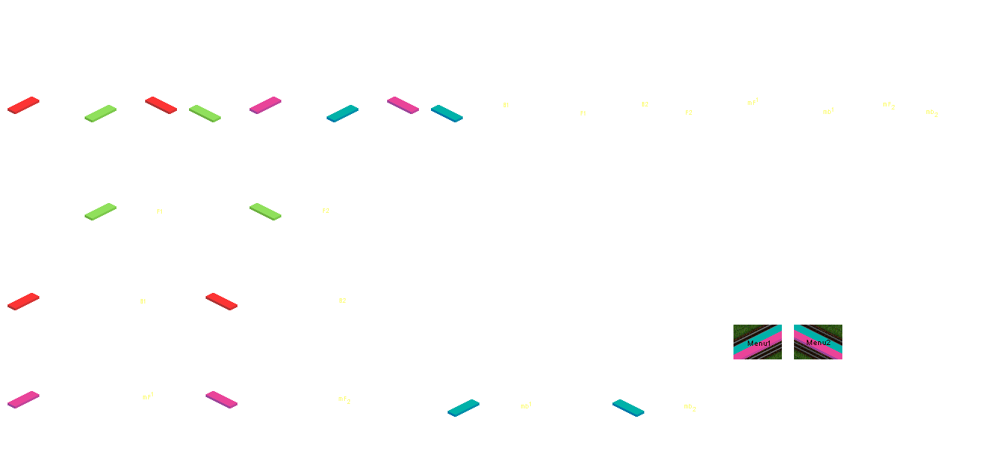  
Zoom in (real dimensions: 1300 x 600)  
Template_RegularPlatform_32bpp.png [ 24.45 KiB | Viewed 67 times ]

So just the platforms with a completely transparent background (in this case dont forget to also delete the yellow letters/numbers). This is the graphicsfile we will use to code. Give it a name that is logical for you.  
  
So, lets see if we can code that and see how it looks ingame. 8-)  
For now we only have to change the paths to the graphicsfile in the code. (the good old simple Windows Notepad will be good enough for doing that)  
In the code you can see two graphicsfiles being adressed like this:

**Code:**

11 c:/grfcodec603/auzstations/gfx/template_regularplatform_8bpp_EMPTY.png  8bpp   10   40   64  122  -31  -91 normal chunked  
| c:/grfcodec603/auzstations/gfx/template_regularplatform_32bpp.png  32bpp  10   40   64  122  -31  -91 normal chunked

Do NOT change the name or path to the one with the _EMPTY.png extension! Also make sure that this file stays in the gfx folder!!   
(short explanation, I have prepared the code in such a way that you can use 32bpp graphics, so all colors of the Rainbow, not being limited to the pallettes. However the code does require a standard oldschool 8bpp graphicsfile before replacing them with the 32bpp one, even though they dont have to have any graphics in them. Dont ask me why, it just does :cucko:)  
  
But do replace all the paths to this graphicsfile:

**Code:**

template_regularplatform_32bpp.png

with a path to your newly made graphicsfile.  
  
Save the .nfo and recompile the GRF and see if your graphics will now turn up in the game. :twisted:  
With a bit of luck this should work to check your graphicsfiles, when you have drawn another graphicsfile, you can replace the path in the code to that one and see if those graphics are ok too.  
  
I think that is enough homework for the time being :P  
If you have two graphicsfiles that are ok, we can go on with expanding the code to have both graphicsfiles in it. Then I will also go deeper into explaining the basics of the code that you need to change when expanding the code and how to renumber the codelines.  
But first, try to get some graphicsfiles, I'm off to bed.... :yawn:  
Please also post these graphicsfiles if they are ok, so I can place them in my compile factory for the next steps.  
Good luck!! :W